**LAPTOP REQUESTING CATALOG ITEM**



**Team ID: NM2025TMID17422**

**Team Leader: ILAYAMATHI M**

**Team Member 1: YAMUNA DEVI S**

**Team Member 2: LEEMA N**

**Team Member 3: KAVIYARASI C**

**Problem Statement:**

Employees need a faster and more efficient way to request laptops for their work. The existing process is manual, often causing delays and lacks interactive form elements to guide users or guarantee accurate data input. To solve these issues, a Service Catalog item must be created that enables users to easily submit laptop requests, includes dynamic form fields, clear guidance, and functionalities like form reset. Additionally, all modifications should be tracked to ensure governance and deployment compliance.

**Introduction:**

In the current fast-moving work environment, providing employees with necessary equipment such as laptops promptly is critical for productivity and smooth onboarding. However, the organization's current laptop request procedure is manual, inconsistent, and prone to delays due to incomplete or incorrect submissions.

To enhance and simplify this workflow, a Service Catalog item will be built within the IT Service Management platform. This item will offer a self-service front end where employees can straightforwardly and accurately request laptops. Key features include:

* Dynamic forms that show or hide fields based on user selections
* Clear instructions and validation checks to prevent submission errors
* A reset option to quickly clear the form and start over if necessary
* Tracking of all changes to support governance and auditing

This implementation will lower processing time, increase data accuracy, and provide a better user experience.

**OBJECTIVE:**

* *Employee Submission:* An employee logs into the service portal and selects the “Laptop Request catalog item”. They are presented with a form to choose a laptop model, provide justification, and select any required software or accessories.
* *Manager Approval:* The request is automatically sent to the employee’s manager for approval. The manager can approve or reject the request with a single click.
* *IT Fulfillment:* Once approved, the request is automatically assigned to the IT fulfillment team. The team receives all the necessary details in one place, which helps them process the order and prepare the laptop for the user.
* *Delivery and Closure:* The IT team updates the request status as they prepare and ship the laptop. Once the laptop is delivered and confirmed, the request is marked as complete, and the asset is automatically recorded in the asset management database.

**Project Steps: LAPTOP REQUESTING CATALOG ITEM**

To ensure a successful and efficient implementation of the Laptop Requesting Catalog Item, the project split as milestones. To achieve the milestones the implementation should be done by the following key steps:

1. **Create Local Update set:**

1. Open “ServiceNow”.

2. Click on All >> Search for “Update sets”

3. Select “Local update sets” under “system update sets”

4. Click new to create an update set named “Laptop Request”.

5. Click on submit and make current

6. By clicking on the button it activates the update set.

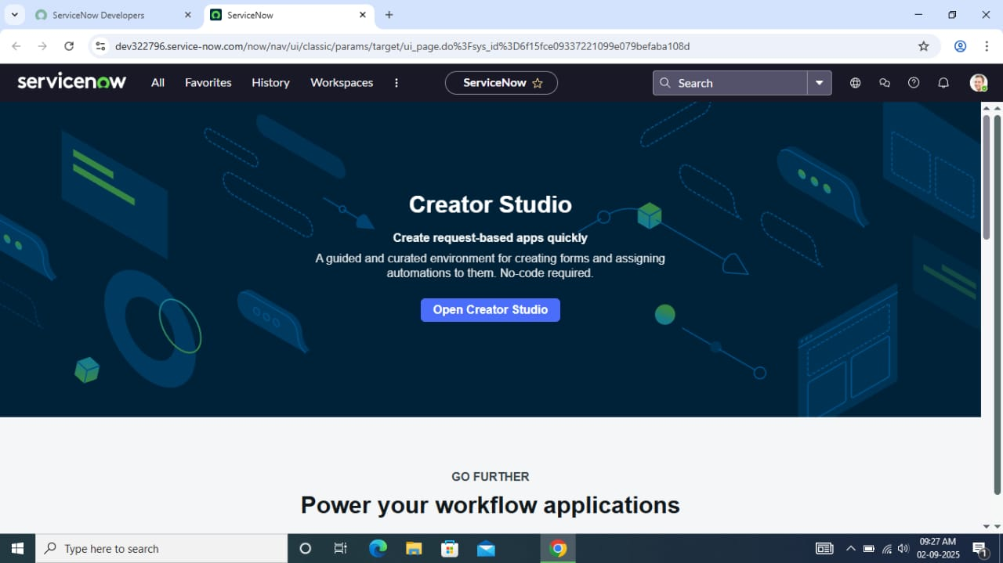

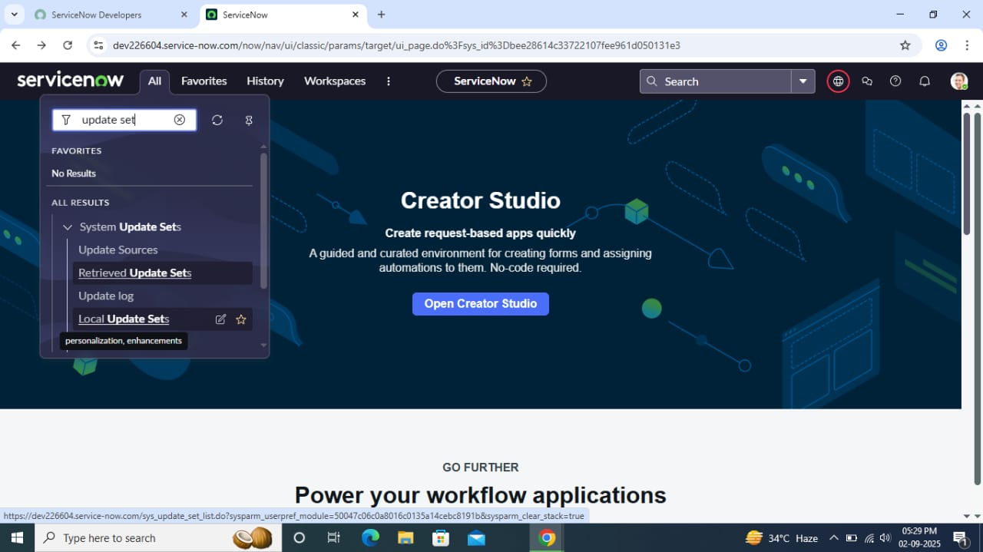

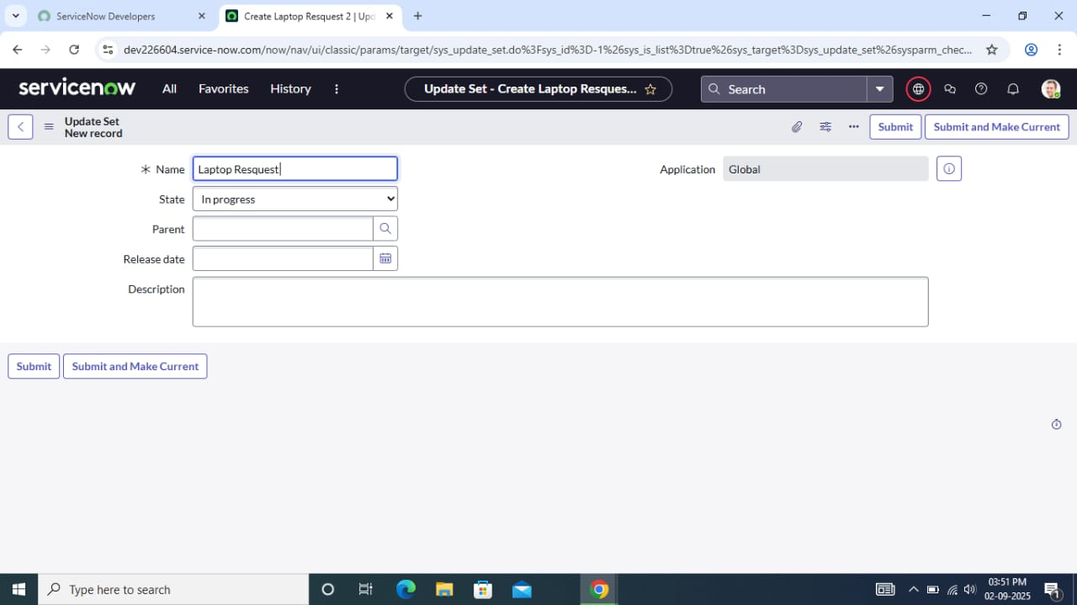

NOTE: Perform all the actions under this newly created update set only.

1. **Create Service Catalog Item:**
   1. Open “ServiceNow “.
   2. Click on All >> service catalog >> Maintain Items.

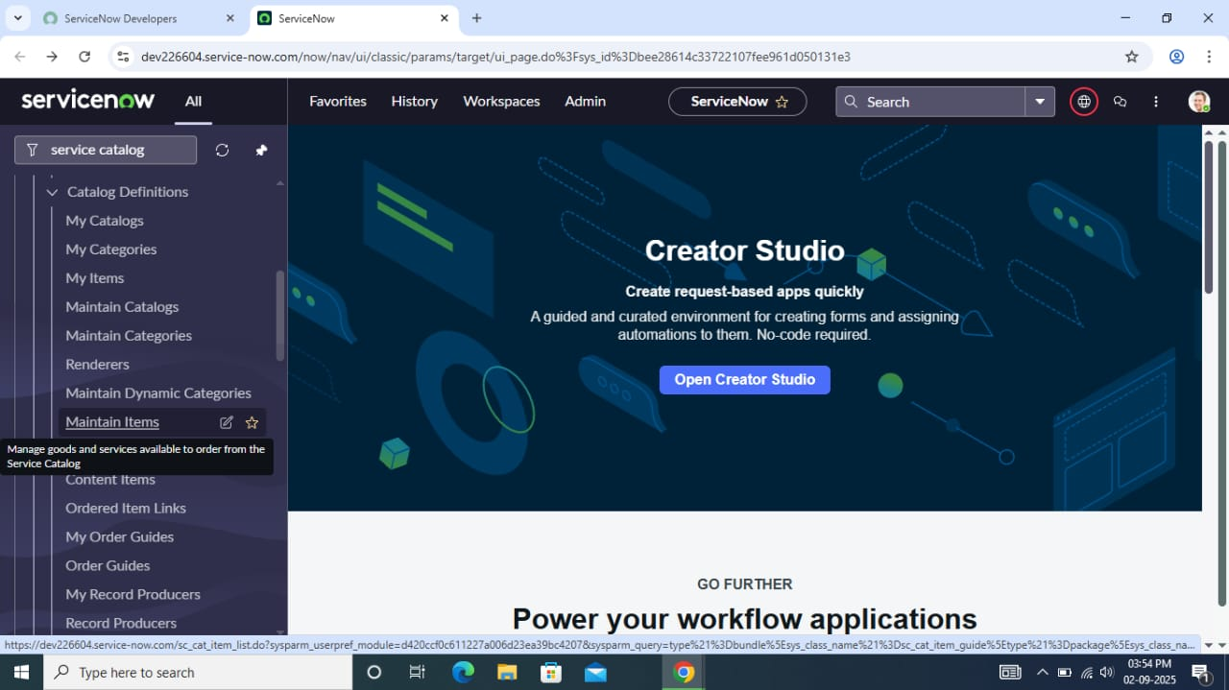

* 1. Click on New and Fill the following details to create a catalog item

Name: Laptop Request

Catalog: service catalog

Category: Hardware

Short Description: Use this item to request a new laptop

* 1. Click on ‘SAVE’

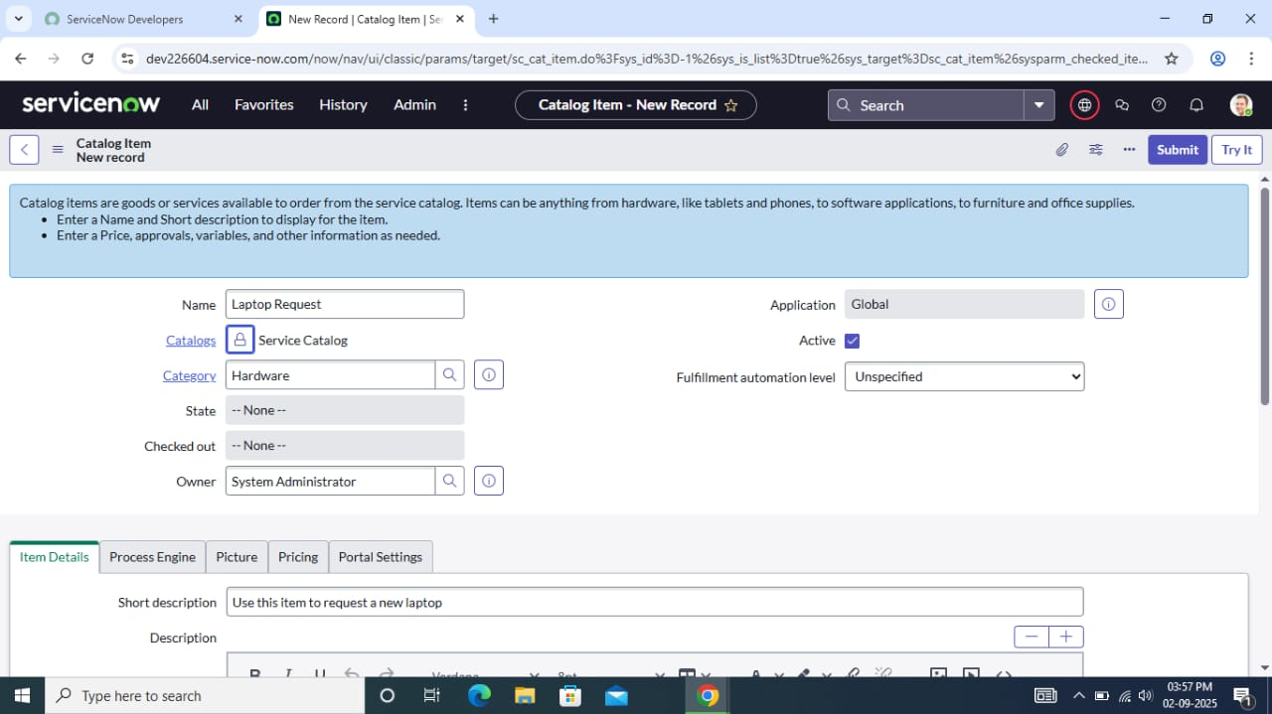

**Add Variables**

**Step1:**

* After saving the catalog item form scroll down and click on variable (related list)
* Click on new and enter the details as below
  1. Variable 1: Laptop Model

Type: Single Line text

Name: laptop_model

Order: 100

* Click on submit
* Again click on new and add Remaining variables in the above process

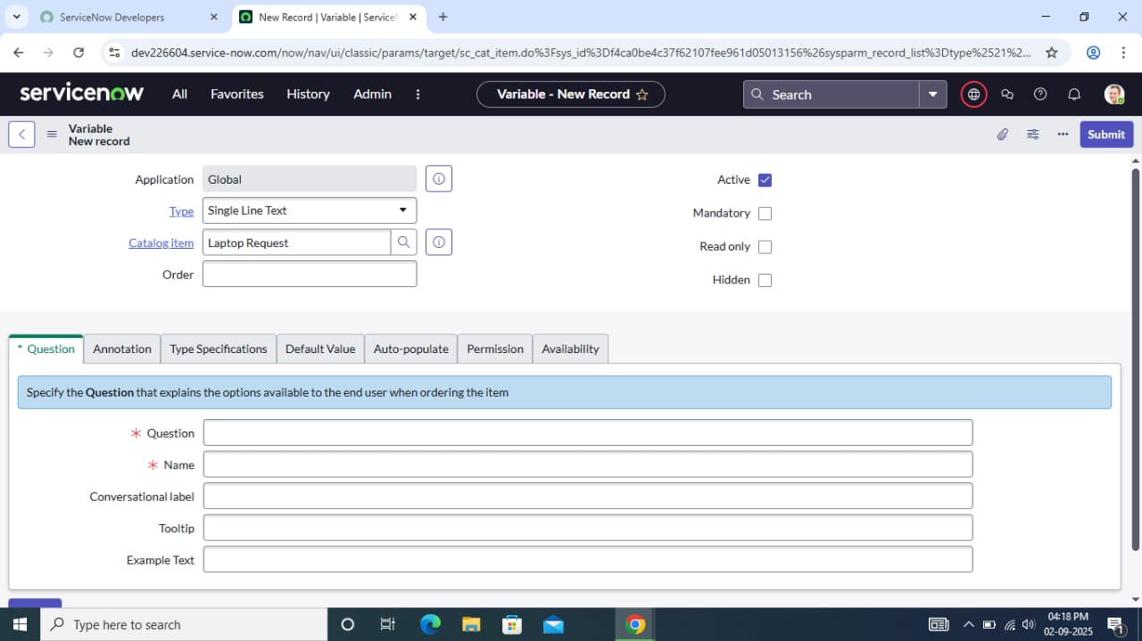

* 1. Variable 2: Justification

Type: Multi Line text

Name: justification

Order: 200

* 1. Variable 3: Additional Accessories

Type: Checkbox

Name: additional_accessories

Order: 300

* 1. Variable 4: Accessories Details

Type: Multi Line text

Name: accessories_details

Order: 400

**Step 2:**

* After adding above variables in newly created catalog item, save the catalog item form

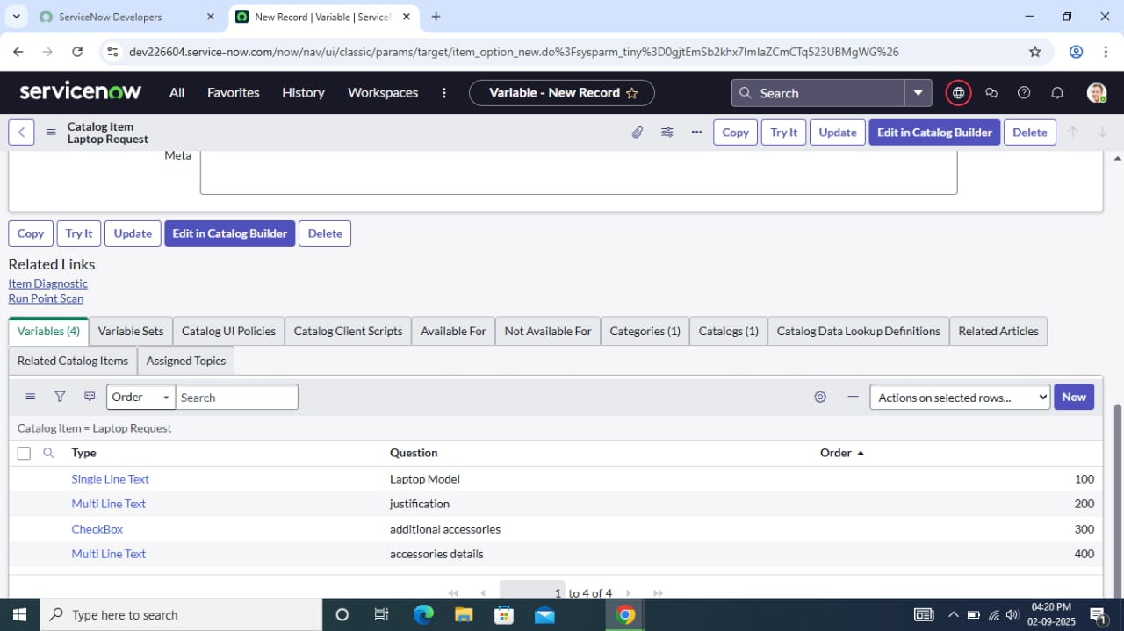

**3. Create Catalog Ui policies**

1. Navigate to All >> Search for “Service Catalog “
2. Select “maintain item” under “catalog definition”
3. Search for ‘laptop request’ which is previously created
4. Select ‘laptop request’ and scroll down then click on “Catalog Ui policies”
5. click on new in the catalog ui policies related list tab
6. Give short description as :”show accessories details “
7. Set the catalog condition in the related list tab ‘when to apply’

[field: additional_accessories, operator: is, value: true]

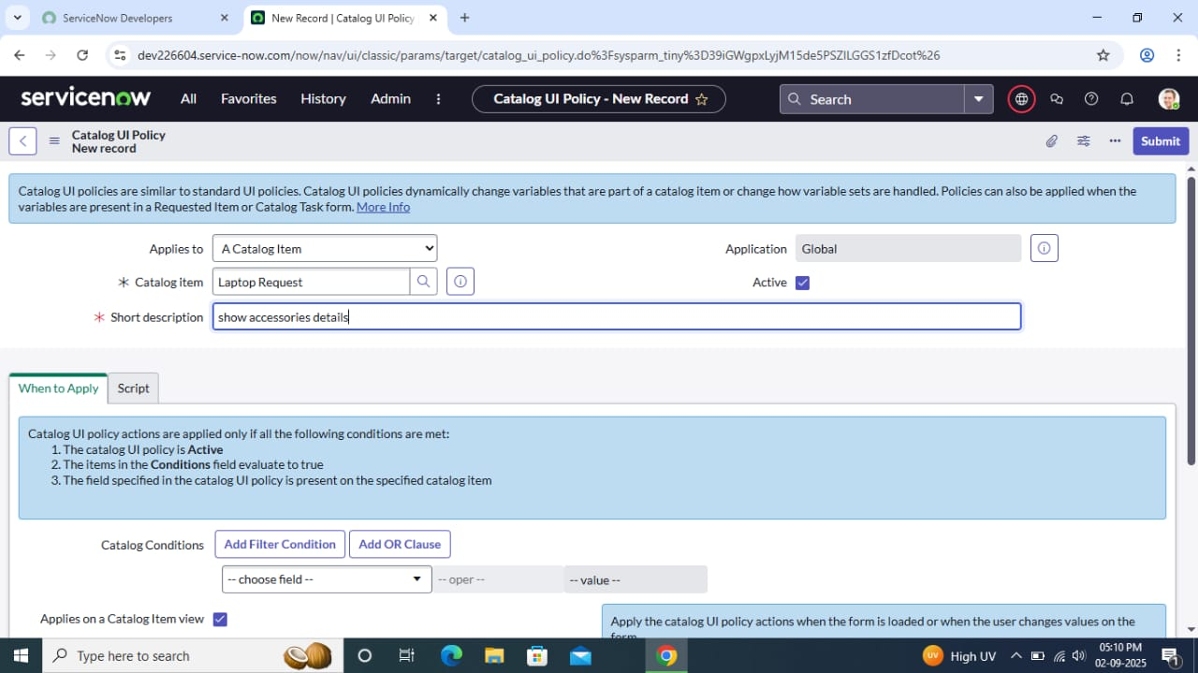

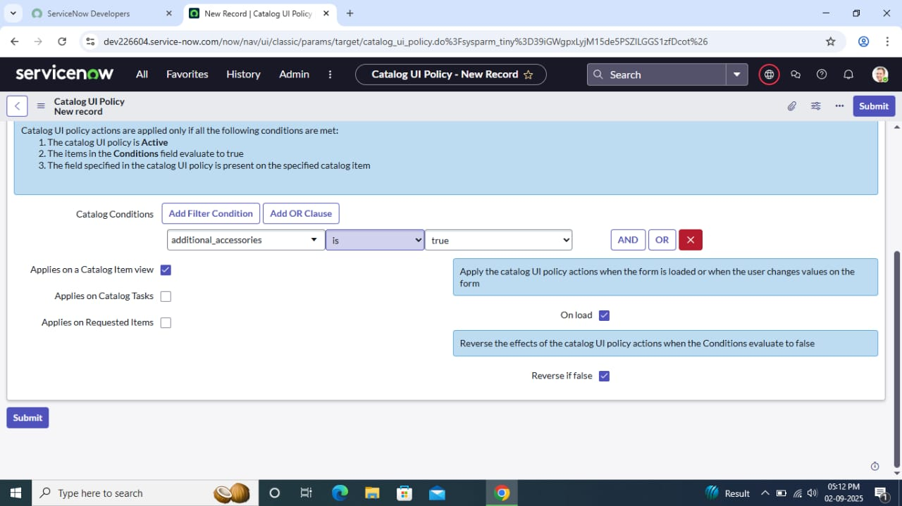

1. Save the UI Policy **(do not click on submit)**
2. Scroll down and select ‘catalog ui action’ and click on new button
3. Select Variable name as: accessories_details

Order: 100

Mandatory: True

Visible: True

1. Save the Catalog UI Action, then save the entire UI policy form.

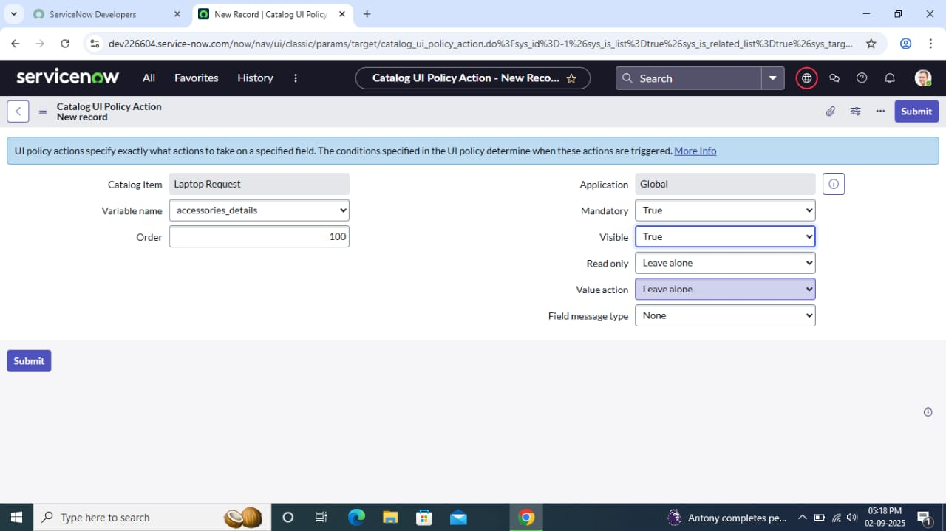

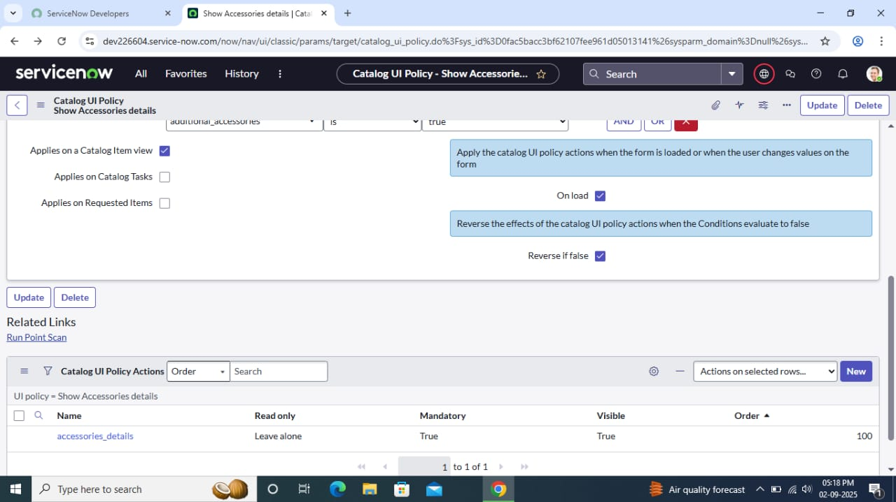

**4. Create ui action**

1. Open “ServiceNow “
2. Click on All >> Search for “ui action “
3. Select “ui action” under “system definition”

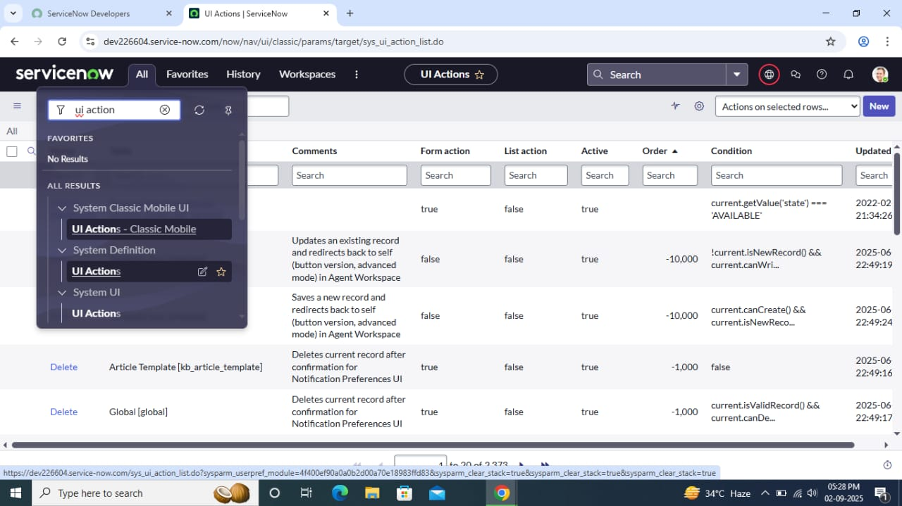

1. Click on new and fill the following details to create ui action

Table: shopping cart(sc_cart)

Order:100

Action name: Reset form

Client: checked

Script:

function resetForm() {

g_form.clearForm(); // Clears all fields in the form

alert(“The form has been reset.”);

}

1. Click on save

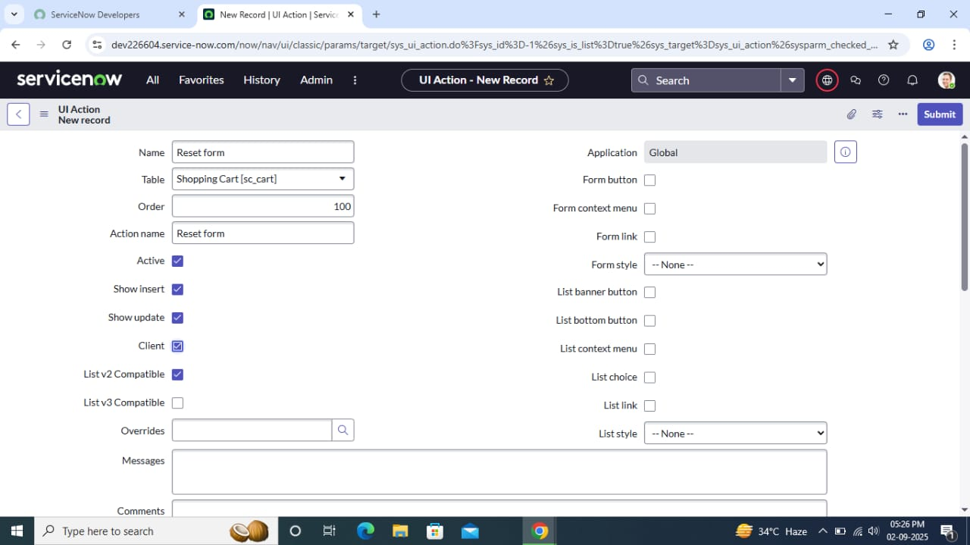

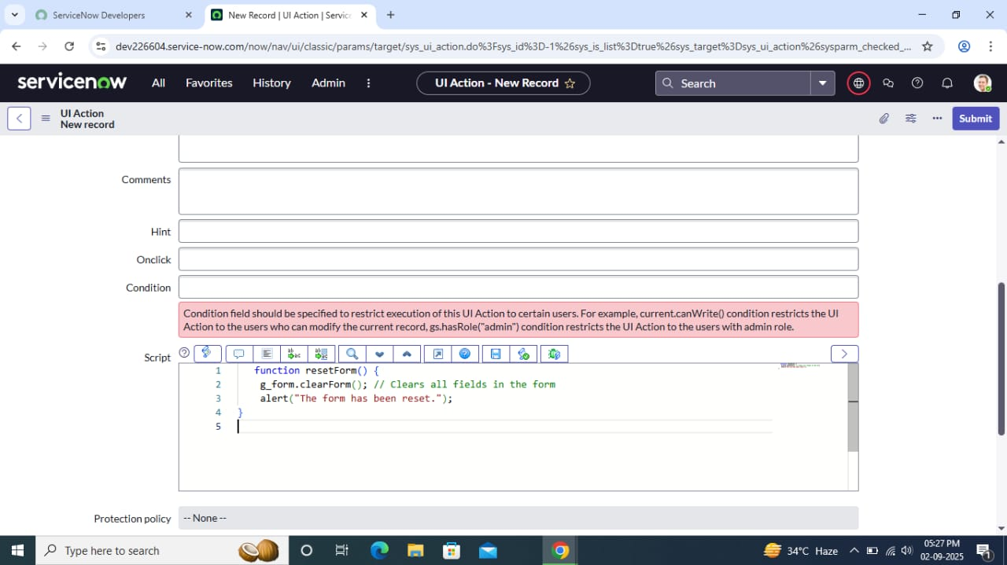

**5. Exporting changes to another instance**

1. Click on All >> Search for “update sets “
2. Select “local update set”
3. Select created update set (‘Laptop Request Project’)
4. Set the state to ‘Complete’
5. In the related list Update tab, updates are visible which we perform under this update set
6. Click on export to XML, it download one file

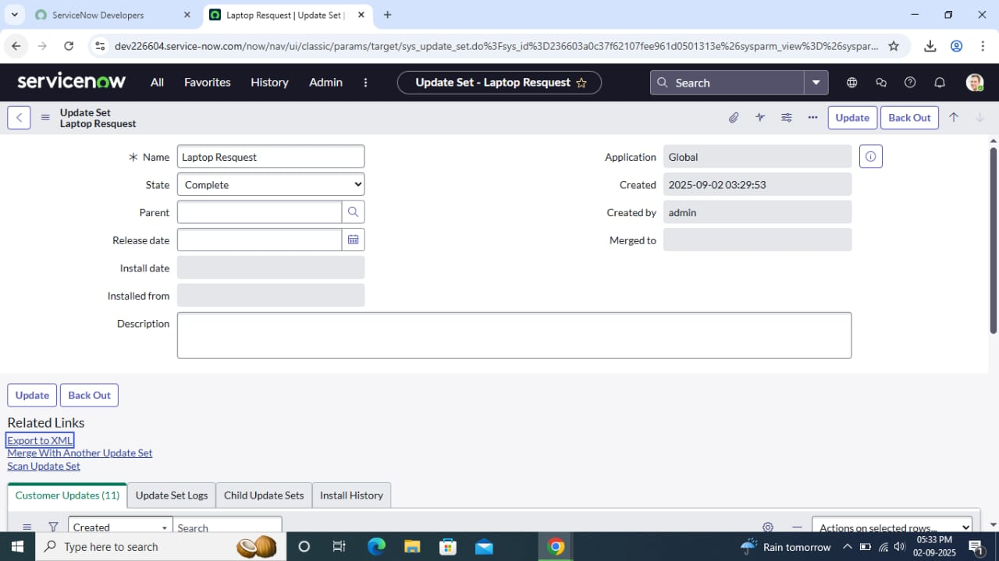

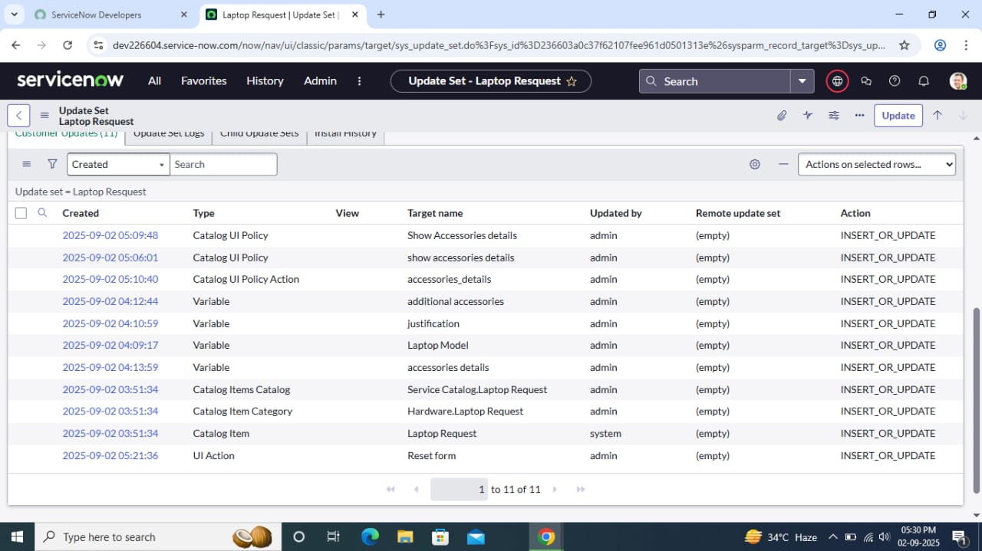

**6. Retrieving the update set**

1. Open another ServiceNow instance in incognito window
2. Log in with credentials
3. Click on All >> Search for “update sets “
4. Select “Retrieved update set “ under “system update set “

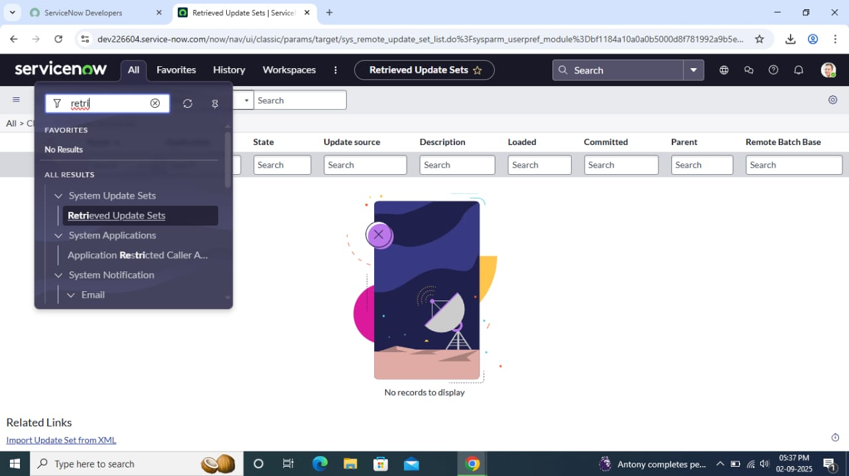

1. It open retrieved update set list and scroll down
2. Click on “Import update set” from XML.

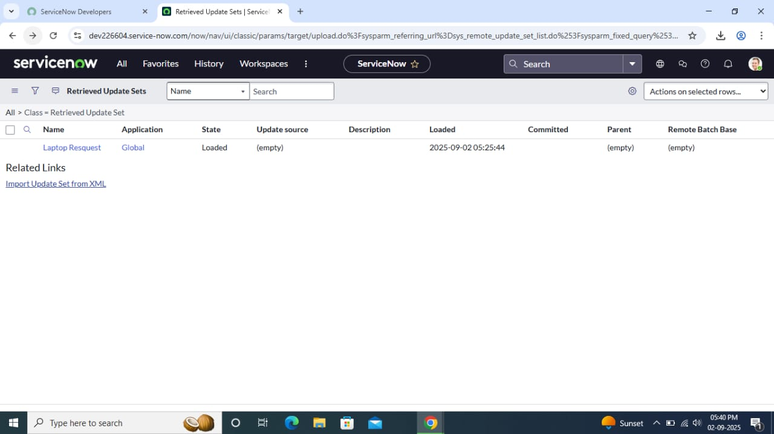

1. upload the downloaded XML file and Click on “Upload “.

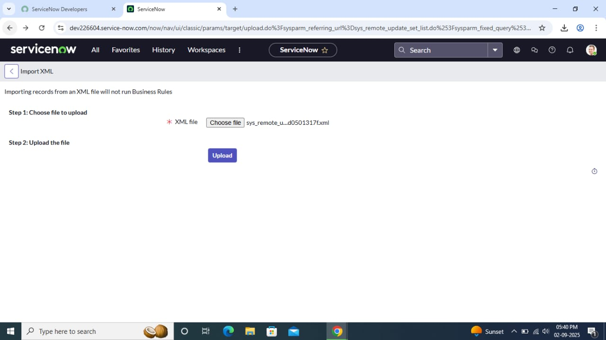

1. Open retrieved update set ‘laptop request project ‘
2. Click on “preview update set” and click on “commit update set”
3. Now we can able to see the related tab updates
4. After completing update set in this instance we get all updates which are done in the previous instance

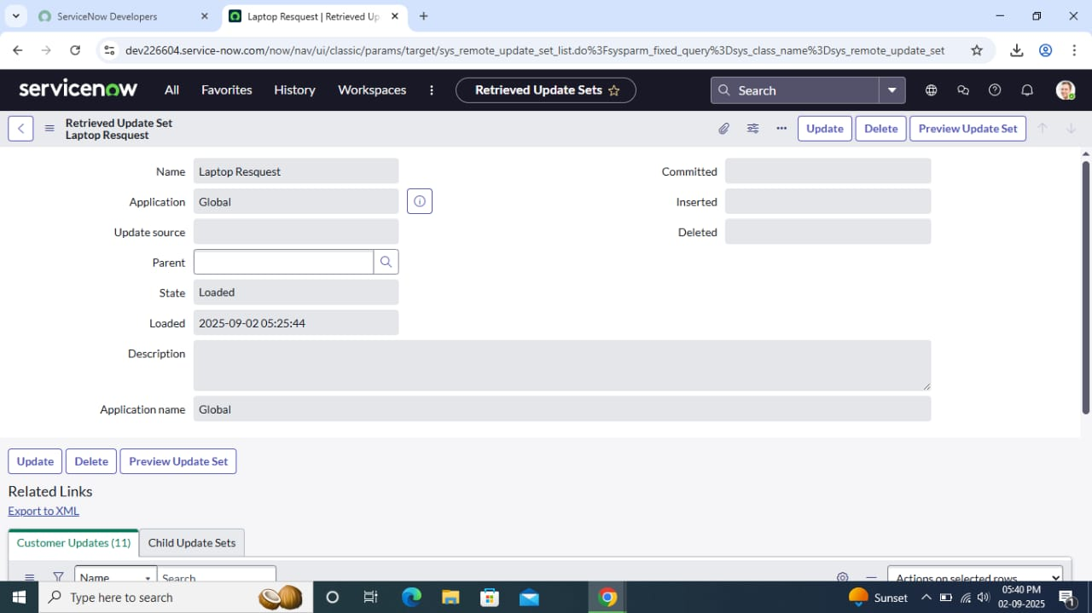

**7. Test Catalog Item**

1. Search for “service catalog” in application navigator in target instance
2. Select “catalog” under “service catalog”

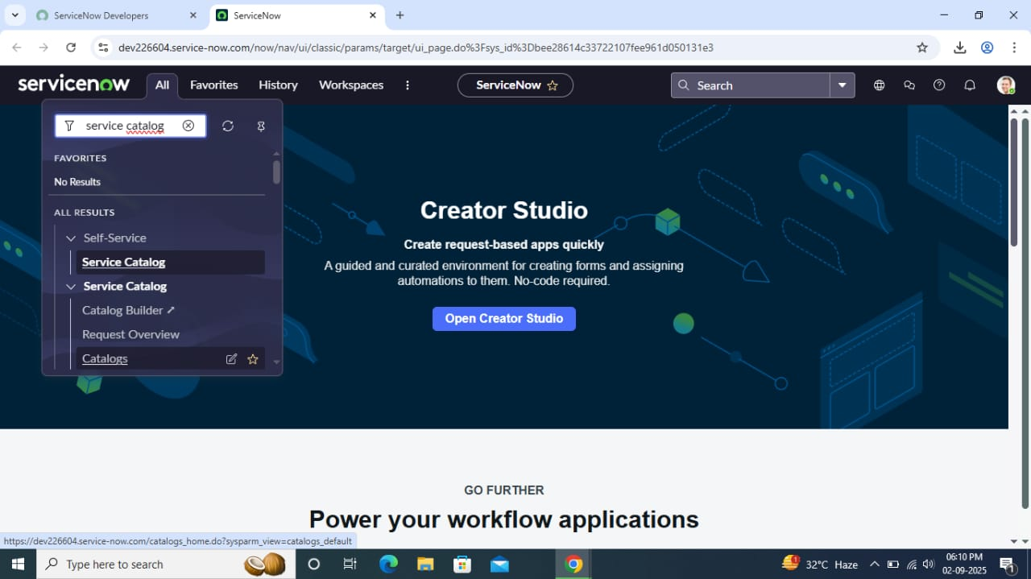

1. Select hardware Category and Search for “laptop request item”

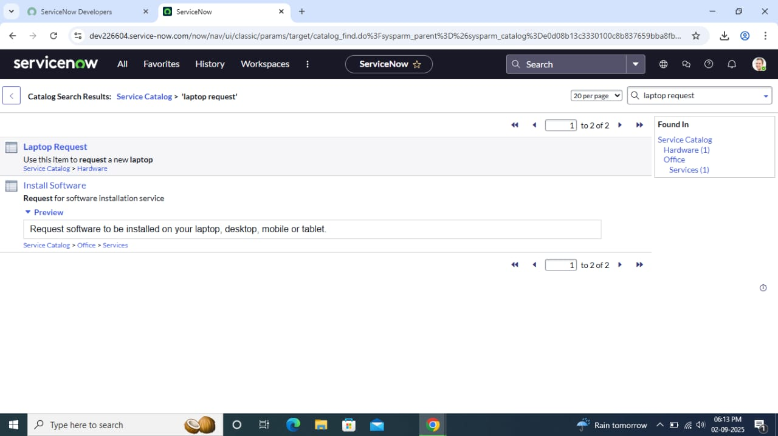

1. Open the item and verify only three variables appear at first.

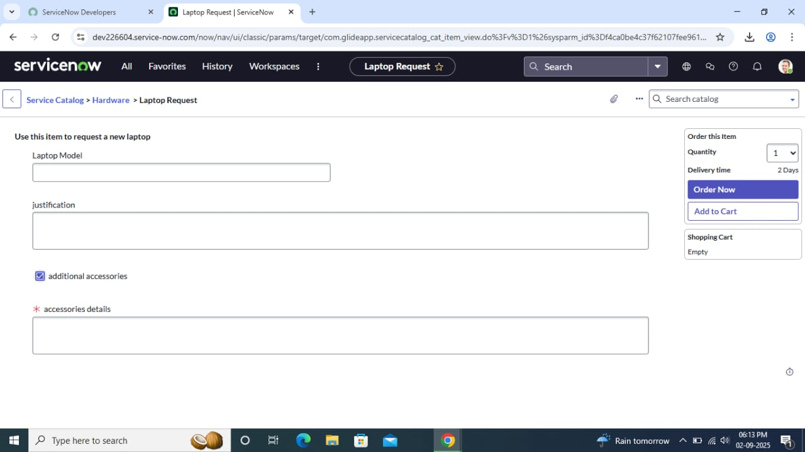

1. Check the “Additional Accessories” checkbox and confirm that the "Accessories Details" field becomes visible and mandatory.
2. Validate that the dynamic form works as expected, matching the specified requirements.



**Conclusion**

The Laptop Requesting Catalog Item project effectively simplifies the laptop procurement process within the organization by utilizing ServiceNow’s Service Catalog functionalities. By implementing a dynamic and user-friendly catalog item, it reduces errors, accelerates request processing, and improves end-user experience. This project is an example of replacing manual and error-prone procedures with an automated, efficient, and user-centric approach—enhancing both service delivery and employee satisfaction.